# Linking to videos on Wistia and Setting up the Flare topic

All videos reside on Wistia. Link to the videos from Flare topics. You need Administrator credentials to upload and access the Embed codes. Ask Matt Raymond (Hopkinton) for Administrator credentials.

## Setting up the Flare topic

* Many of the Flare topics that link to videos on Wistia are titled “Learning how: *Description*”
* The file naming convention is Video_*description*.htm. This makes it easy to identify topics with links to videos. Some files are also named ViewVideo_*description*.htm (file names evolved).
* Note the differences in how Print versus Online looks in the topics. I used conditions in topics so that Print links to the video and Online plays the video in the topic (but it still links to Wistia).

### Example Print and Screen conditions.

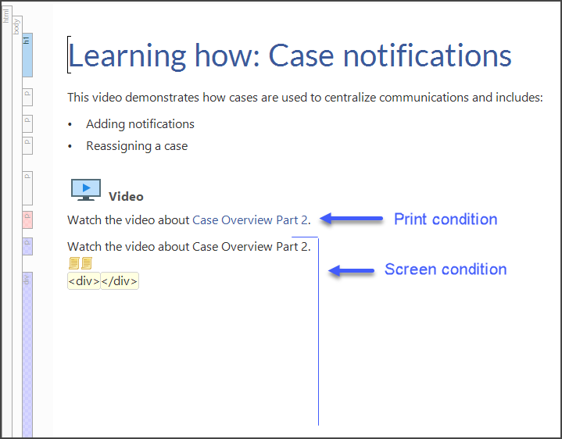

## How to setup the Screen link

**Before you start this process**, set up the Flare topic. I recommend copying content from a topic that already has a Wistia link. For example, use CasesTasks/ViewVideo_Part2.htm (example shown on previous page). It is much easier to copy a topic than to set up a new one because a new topic requires more edits to the code. Flare does not like async by itself – you have to change to async=”async”. So if you copy an existing topic, then you only have to paste the video identifier, as highlighted in the screenshot.

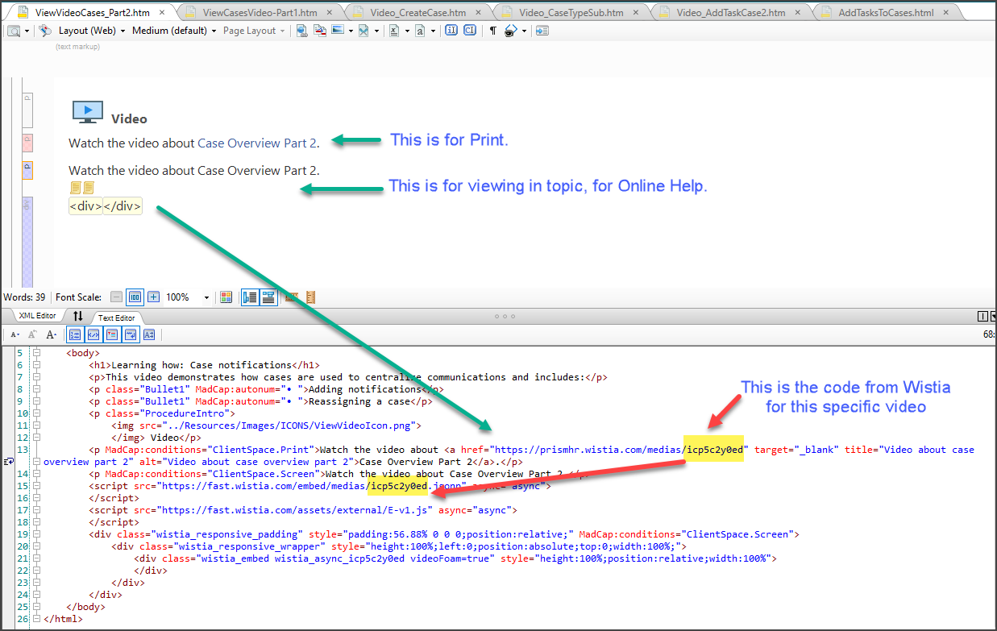

1. Create the Flare topic.
2. Login to Wistia with Admin credentials.
3. Select **PrismHR ClientSpace**.
4. Locate the video and open.
5. Click **Embed & Share**.
6. A form appears with the Embed Code.
7. Copy the highlighted part. This is the video identifier:

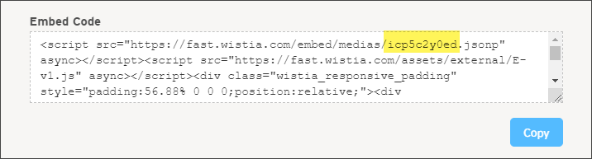

1. Paste the identifier in the code of the Flare topic. It goes in 2 places:



1. Generate Help and Print and test the links.